* + 1. **Future plan**

At the moment, ECRM system just support teacher view their schedules in application. What we are going to do is synchronizing all schedule to google calendar for teacher. Furthermore, ECRM system will support reporting equipment in hospital, workplace…

* + - 1. Synchronizing schedule

 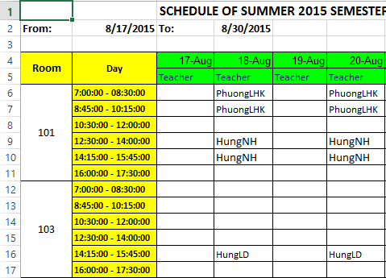

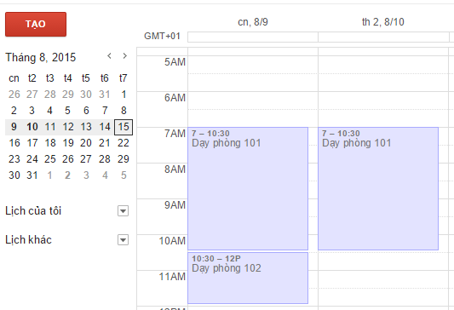

After staff has imported schedule, system will automatically synchronize all schedules to each teacher’s account google calendar.

* + - 1. Manage equipment in workplace